Hello Everyone, Welcome!

We have found a real Hidden Gem, Thank YOU for joining us to find out what this GEM is!

Many of us have joined a "Collaborative Economics" community that has found a Simple and Easy way to change our financial situation. The best part is...

**It is Only $1.00 ever! That’s right just four quarters!**

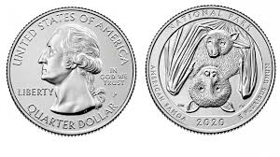

By working methodically together we can make **$2000 every week, not every month...**

**Every Week!!!**

We are doing this deliberately and intentionally and with control...spacing our efforts

out twice a week...with only one dollar and only 3 people to start**. The right 3 people**...

3 people who really want to change their financial situation in just 6 weeks!

Who doesn’t have a dollar? Who doesn’t want $2000.00 weekly in just 6 weeks?

Too good to be true, that’s what I thought too! Please see it and then say no, but don’t

say no until you’ve seen and given me your answer, OK?

There are live calls on Monday and Thursday...

**Hidden Gem presents... The world’s best kept secret! SUCCESS WITH FOUR QUARTERS!**

Please join us Monday and Thursday at 8:30 PM eastern 7:30 PM central

6:30 PM mountain 5:30 PM Pacific.

PILOT PROGRAM Purpose; **6 week goal is $2000 every week.**

[**https://zoom.us/j/2271815675**](https://zoom.us/j/2271815675)

Telephone: 1-646-558-8656 ID: 227-181-5675 (US New York) 1-720-707-2699 ID: 227-181-5675 Canada 1-647-558-0588 ID: 227-181-5675

Join our Cloud HD Video Meeting set up ZOOM now: <https://zoom.us>

This call is only a half hour because the Hidden Gem concept is so simple to explain!

HERE IS EARLIER RECORDED CALL TO GET YOU STARTED NOW AND BE READY FOR MONDAY! [**https://bit.ly/2SBY7fF**](https://bit.ly/2SBY7fF) We are going to make this happen!

In a nutshell...

We are committing to this deliberately, intentionally and with disciplined controlled spacing on Mondays & Thursdays! This is our PILOT PROGRAM and we want YOU to join with us to make it happen for all of us!

QUESTION! $1MM or receive a penny doubled every day for 30 days?

We are using the magic of compounding that is as simple as doubling a penny for 30 days,

only we have created a realistic process using this compounding miracle!

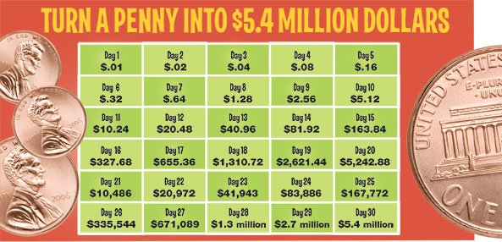

**Starting March 2nd**

**It’s only a dollar...it’s only 3 people. The right 3 people. 😉**

We’re looking for people who want to change their financial situation! Is that you?

You can do this too because you are only looking for three people that you

**Know, Like and Trust** that will **Commit,** **Pay Attention and Work Together with Us**!

We are keeping it simple...not over complicating or processing it.

This can easily be done offline too!

Only through word of mouth or Messenger/ text/ email...not posting on FB or any other

social media.

In this way we keep our network organic...friends & family. It will only take 39 people in your network to accomplish this in 6 weeks. BUT you only need three people that commit to do what you do!

At the seventh week we continue to receive $3k every Tuesday... keep $2k and send $1k to our sponsor.

Let’s take a closer look!

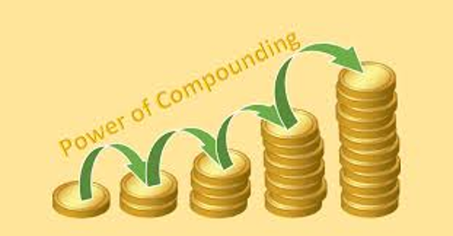

So, look at the chart below and starting next Monday March 2nd...we will complete

2 levels per week for 6 weeks.

This is going to work with this **deliberate systematic process**...and we will have fun too!

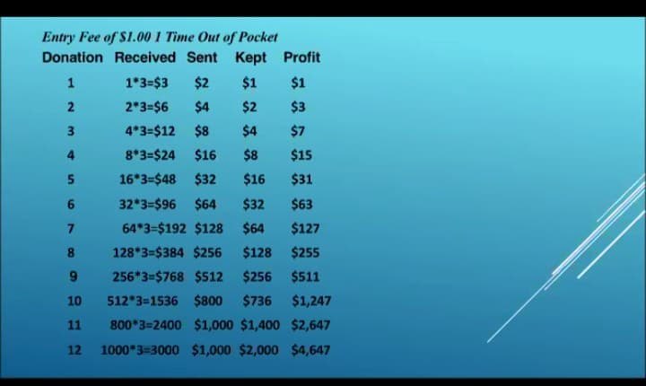

It's a donation program. All YOU need is $1 to start and 3 people you know with $1. Who want $2000.00 a week too!

For the first donation those three people send you $1 each, that's a total of $3. Your first donation to your sponsor is $2. So, on your first level your profit is $1 ($3 received minus $2 sent).

On the second level your three people double the donation that they send you so instead of $1, they now send you $2 each for a total of $6 received ($2 x 3 people). The donation that you also send your sponsor is doubled, so on the second level you will send $4. $6 received minus the $4 you sent for your second donation to your sponsor equals $2. The $1 profit from the first level + the $2 profit from the second level equals a total of $3 thus far. From that point on every donation that you receive doubles and every donation that you send doubles according to the chart.

**"Collaborative Economics"**

The relationship is with You & your 3 people...and them with theirs...keeping it tight and with intent and commitment. Isn’t it worth it to give it a committed try? It’s you with Four Quarters and your 3 People with their Four Quarters, that’s it!

**We need to take our economy into our own hands!**

**THIS USES THE POWER OF COMPOUNDING! NO RISK! A GREAT REWARD, EVERYONE WINS!**

**WE USE THE KISS METHOD SO EVERYONE WINS!**

**Keep It Super Simple!** There is no website needed, no administration to deal with, no charting or graphs, no advertising required, you are the leader of your three family members or friends, and everything is in your control! Funds transfer is peer to peer via several methods that may be available in your area. Bank to Bank etransfers, Cash Card, Crypto exchanges, Zelle, paytm,

Google Pay, Skrill and direct physical payment within your local group are some of the options available.

**There is a Telegram group for people who are committed to the process.**

Let’s open up for any questions now.